Medical and Dental Students

All students planning an overseas or UK elective are required to attend an appointment at Occupational Health as part of overall preparation for the experience.
QMUL Occupational Health Service will help you prepare for your elective.
We can:
- Certify vaccination records and carry out blood tests to meet health clearance requirements for your host hospital/clinic
- Provide advice on all vaccinations needed for your trip
- Advise on malaria prophylaxis
- Prescribe an HIV emergency treatment pack

Many tests and vaccines are provided free of charge, or we can help you to source these either free of charge or at the lowest cost

Contacting Occupational Health
The OH service holds clinics on nearly every day of the week. You may need to attend on more than one occasion if you need a lot of vaccinations or tests.
Arrange your first appointment 2-3 months before you go.
Bring these items with you to your appointment:
- Any vaccine record card or other information on travel vaccinations you have had in the past
- Any information/ forms sent to you by your host hospital about their health clearance requirements

Occupational Health Support for Electives

Occupational Health Service
Most hospitals in USA, Canada, Australia or New Zealand require documentary evidence of immunity against hepatitis B, rubella, measles, mumps and chicken pox. Many also require tests to exclude TB infection. If a chest x ray is needed you will be given a request form to take to Trust x ray facilities.

Some hospitals insist on a medical examination. If this is necessary, the OH adviser should be able to arrange an appointment for you with the OH physician.
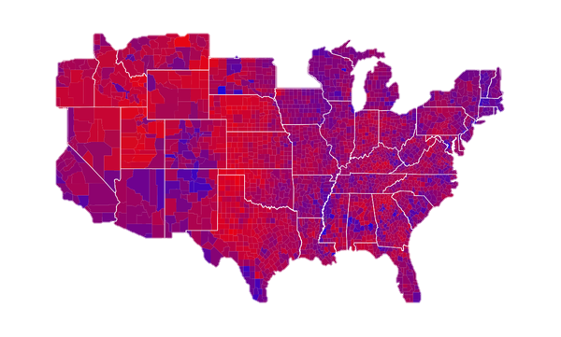
It can take up to 8 weeks to complete clearance procedures. You should attend OH at least 2 months before the closing date for applications. Bring the letter and/or health information form sent to you by your host hospital or clinic that details their clearance requirements, to your first appointment.

Some hospitals in Australia and New Zealand also require MRSA screening just prior to your going on elective. OH can make arrangements for doing this when you attend for vaccinations.

There may be a charge for chest x rays and MRSA screening tests.

Travel Vaccinations and Health Advice

OH staff use the main UK reference database to advise you on appropriate health precautions for travel. You should find out general recommendations for the countries you will visit at the patient accessible part of this website:

www.fitfortravel.nhs.uk

OH will help you to plan a specific vaccination programme based on a risk assessment that considers your health, where you will live, what you will be doing ,your length of stay as well as your destination.
If your 5-year hepatitis B booster dose is due within 12 months of your elective visit we will administer this.

Malaria prophylaxis.
If you need malaria prophylaxis, we will advise on the available regimes and can prescribe these on a private prescription. You would then purchase the drugs at a high street pharmacy who will charge you the retail cost of the drugs. Drugs for malaria prophylaxis cannot be supplied on NHS prescription.
The cost of the drugs will be between £40 & £180 depending on your choice of drug regimen. For information on the pros and cons of different regimens see
NHS Clinical Knowledge Summaries - Clinical topic - Malaria prophylaxis...Choice of drug
Charges for OH services

We will make no charges for:

- Documentation and certificates
- Vaccines which relate to your ‘healthcare worker’ status in the UK.

(We will advise on the lowest/no cost option for some vaccines as appropriate)

We will need to charge you for:

- Vaccinations required only for the holiday component of your elective
- Malaria prophylaxis (payable to the pharmacy that dispenses your prescription)
- HIVPEP kits (payable to the pharmacy supplier)
- Medical examinations in some cases
- Tests which do not form part of your UK medical student health clearance

HIV Emergency treatment packs

- If your elective is in a country where HIV prevalence is higher than 1% we recommend that you take an HIV emergency treatment pack, unless you know that you host hospital has an HIV post-exposure prophylaxis (HIVPEP) programme that you can use and which can start you on treatment within 1 hour of an exposure.

- You can find out the HIV prevalence for most countries on the AVERT website www.avert.org/aids-statistics.htm

- It is especially important to take an HIVPEP kit if your elective involves surgery, obstetrics or trauma care: risks of needle-stick injuries will be higher.

- HIVPEP kits contain 5 days of drugs. This should be sufficient to protect you whilst you arrange to obtain a further supply from doctor in your host country or return to the UK for the remainder of the 28 day course of treatment. HIV drugs equivalent to those used in the UK and doctors experienced in their use are now easily accessible in almost all countries where HIV is common.

- The prescription is supplied by the QMUL OH Physician on private prescription. The cost is £50-£100. If you want to take a HIV PEP kit.

Personal medication

- If you need to take any prescribed or over the counter medications regularly, take enough with you to cover your whole trip plus an extra 1-2 week's supply in case of delays, and take a copy of your prescription with you

- If you have suffered from asthma in the recent past, but no longer require medication, take a reliever inhaler with you: just in case it re-activates.

- If you will be working or travelling in areas where you will be more than 24 hours away from emergency medical facilities, you may need to ask your GP for prescription for ‘emergency’ antibiotics.

- You should also take a small supply of a simple analgesic/ antipyretic — Paracetamol or ibuprofen— and an anti-diarrhoeal drug— loperamide is the usual best choice. Also take a first aid kit and, depending on your destination, sunscreen and insect repellent.

- When travelling you should carry all medicines in your hand luggage. If you need to transport medicines in your hold luggage, pack them in a waterproof wrapping or container the centre of your rucksack. If it is left out in the sun at an airport or on top of a bus & they are packed near the surface they could be damaged by heat.
http://qm-web.ohsd.qmul.ac.uk/

