Staff Equality, Diversity and Inclusion Data

Our mission to become the most inclusive university of its kind, anywhere has been inspired by the diversity and quality of our community of students, staff and alumni.

Queen Mary is committed to tackling discrimination, providing equal opportunity for all and strives to create a positive working environment of mutual respect and dignity.

In line with the requirements of the Equality Duty legislation, the University prepares statistics relating to the protected characteristics of its staff annually.

This report complements our 2019 Annual Report and Gender and Ethnicity Pay Gap reports.

Notes and Data Definitions for guidance when using this report

The data contained within this Annual Report – unless otherwise stated – corresponds to the data annually submitted by Queen Mary to the Higher Education Statistics Agency (HESA) for the year 2017/18. This is because, at the time of analysis, the 2017/18 HESA Year was the most recent year for which published sector benchmarking data were available.
‘The HESA Year’
The HESA year includes all contracts taking place during the year 1 July – 31 August each year. It includes those contracts that begin during the year and those that end during the year. The overall numbers of contracts within a HESA year will always be, therefore, greater than the number of contracts on any snapshot date during that year.
Data Definitions
‘Academic’ staff in this report are defined as those contracts of employment that have an Academic Employment Function of 1, 2 or 3 for HESA submission purposes. These are defined as:
- Academic contract that is teaching only
- Academic contract that is research only
- Academic contract this is both teaching and research
Those contracts with a HESA Academic Employment Function of 1, 2 or 3 include Teaching Assistants, Teaching Fellows and Research Assistants.
‘Junior Grades’ refer to those contracts of employment in Grades 1-4 within the University’s grading structure
‘Middle Grades’ refer to those contracts of employment in Grades 5-6 within the University’s grading structure
‘Senior Grades’ refer to those contracts of employment in Grades 7-8 within the University’s grading structure

Graphs 3 to 8 inclusive show the University’s HESA data for the four years up to and including 2017/18. The University’s data for the 2017/18 year is then benchmarked against comparable data for both the Russell Group and the Higher Education sector as a whole
Table of Graphs:
- Full staff profile by ethnicity and grade*
- Full staff profile by gender and grade*
- Age profile of Academic staff
- Age profile of Professional Services staff
- Gender profile of Academic staff
- Gender profile of Professional Services staff
- Ethnicity profile of Academic staff
- Ethnicity profile of Professional Services staff
- Academic staff profile by grade and ethnicity (January 2018)*
- Professional Services staff profile by grade and ethnicity (January 2018)*
- Academic staff profile by gender and grade in 2018/19*
- Professional Services staff profile by gender and grade in 2018/19*
13. Successful Academic staff promotions by ethnicity* (2016 – 2019)
14. Successful Academic staff promotions by gender* (2016 – 2019)

* indicates data not supplied to the Higher Educational Statistics Agency

Graph 1: Staff Profile by Ethnicity and Grade Level

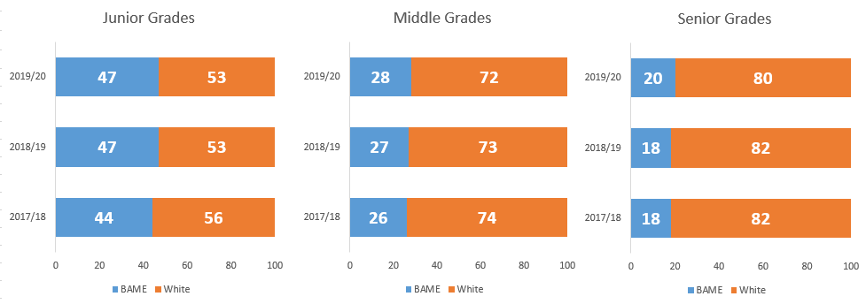
Graph 1 shows how the profile of BAME and White staff at Queen Mary has changed over the last three years. BAME staff make up nearly half of the staff population at junior grades, reducing to around a fifth at senior grades. Over the three-year period, the proportion of BAME staff across all grade profiles has increased, reflecting an increased representation of BAME staff across Queen Mary as a whole.

Graph 2: Staff Profile by Gender and Grade Level
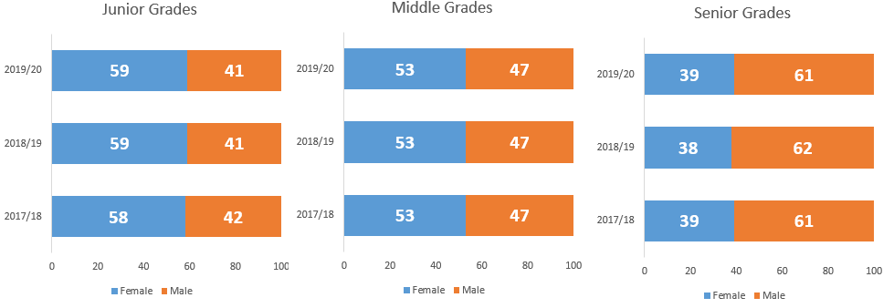
Graph 2 shows the gender profile of Queen Mary staff over the last three years. There has been minimal change in the balance between female and male staff at all levels. Females make up more than half of the workforce at junior and middle grades reducing to 39% at senior grades.

Graph 3: Age Profile of Academic Staff

Graph 3 represents the age profile of our Academic staff. Over three-quarters of Queen Mary’s Academic staff are aged 18 – 49 (78%). This is higher than the Russell Group average of 75%; and it is also above the sector average of 67%. Queen Mary has a greater proportion of younger staff (aged 34 and under) than our Russell Group comparators and the wider sector. This change primarily occurred from 2017/18 when the total number of Academic contracts increased significantly from 2,385 to 3,095. Many of the additional 710 contracts were held by staff aged 34 and under.
The primary reason for the increase in contracts submitted to HESA in 2017/18 with Academic Employment Functions of ‘Teaching Only’, ‘Teaching and Research’ or ‘Research Only’, i.e. why this number went up by such a degree, was due to a reclassification of Teaching Assistants and Teaching Fellows. Previously, those groups had been classified as ‘Atypical’ and those contracts did not, for HESA, require an Academic Employment Function.

Graph 4: Age Profile of Professional Services Staff

This trend of the proportion of younger staff increasing over time is also reflected in our Professional Services staff group, where we can see that in 2017/18, 37% of staff are aged 34 years and under, up from 35% in 2014/15. The percentage of younger staff in our Professional Services staff groups is relatively higher than at other Russell Group universities and across the sector (30% in both cases). The percentage of staff aged 50 – 65 has remained steady for the past three years (24%).

Graph 5: Gender Profile of Academic Staff

The percentage of female Academic staff at Queen Mary has largely remained steady over the past four years (averaging 44 – 45%). Our percentage of female academics is slightly above the Russell Group average (44% compared to 43%). However, overall the percentage of female academics at Queen Mary is slightly below the sector average of 46%.

Graph 6: Gender of Professional Services Staff

In Professional Services, the percentage of female staff has slightly increased to 61% (from 59% in 2014/15). Our current figure is comparable to Russell Group counterparts (62%) and the sector (63%).

Graph 7: Ethnicity Profile of Academic Staff

Approximately 5% of our staff, in the 2017/18 HESA data, were of an ethnic origin that is unknown to the University. Within the academic workforce, 28% self-identify as from BAME backgrounds. This is significantly higher than our Russell Group counterparts (18%) and the sector average of 16%.

Graph 8: Ethnicity Profile of Professional Services Staff

Within our Professional Services population, 36% are from BAME backgrounds. This is three times the average of Russell Group universities (12%). It is also three times the sector average of 12%.

Graph 9: Academic staff by Grade and Ethnicity in 2018/2019

Note: Junior grades (1 to 4); Middle grades (5 and 6); Senior grades (7 and 8) as defined on Page 1
The majority of our BAME academic contracts are in the junior grades [grades 1 – 4] (627 contracts, accounting for 42% of this group). The next highest representation of BAME academic contracts are in the Lecturer grade (192 accounting for 31% of this group).
There is a declining proportion of BAME staff within our academic levels as seniority increases. BAME staff make up 24% of our Senior Lecturers, and 14% of both our Readers and Professors

Graph 10: Professional Services staff by Grade and Ethnicity in 2018/2019

Note: Junior grades (1 to 4); Middle grades (5 and 6); Senior grades (7 and 8) as defined on Page 1
The highest proportion of BAME Professional Services staff are in the junior grades (44%). There is a declining proportion of BAME staff in Professional Services roles as seniority increases. 19%, or 40 staff, are in Senior graded roles compared to 770 BAME people within junior graded roles. The comparable figures for White Professional Services staff are 980 in junior graded roles and 169 in Senior graded roles.
Graph 11: Academic staff by Grade and Gender in 2018/2019

Note: Junior grades (1 to 4); Middle grades (5 and 6); Senior grades (7 and 8) as defined on Page 1
While 51% of Lecturers are female, the proportion of female staff reduces as seniority increases, down to 29% of Professors.

Graph 12: Professional Services staff by Grade and Gender in 2018/2019

In Professional Services at Queen Mary, almost two-thirds of all staff are female (61%). Just over half of all senior managers in Queen Mary’s Professional Services (56%) are female. Just over a third of junior staff are male (36%).

Graph 13: Successful Academic Staff Promotions by Ethnicity (2016-2019)
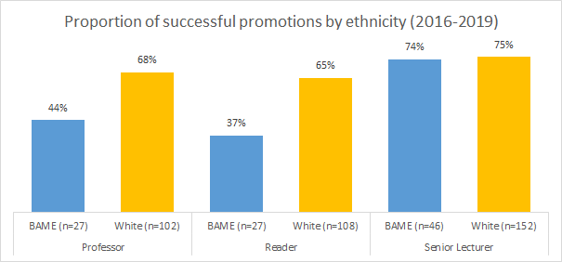
Looking back over the past three years (2016-2019), success rates for White and BAME staff applying for promotion to Senior Lecturer are similar, at the Reader and Professorial level the likelihood of White staff being promoted is significantly higher than their BAME counterparts.

Graph 14: Successful Academic staff Promotions by Gender (2016 – 2019)
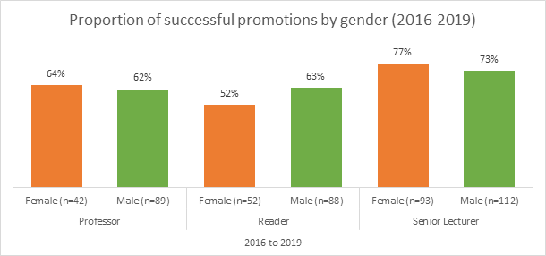
As with ethnicity (above), there is a difference in the success rates of successful promotion to Reader (52% success rate for women compared to 63% success rate for men).

